***Week 06 01 Coding***

***Program 1***

*Given an array A of sorted integers and another non negative integer k, find if there exists 2 indices i and j such that A[i]*

*Input Format*

*1. First line is number of test cases T. Following T lines contain:*

*2. N, followed by N integers of the array*

*3. The non-negative integer k*

*Output format*

*Print 1 if such a pair exists and 0 if it doesn't.*

*Example*

*Input:*

*3135*

*4*

*Output:*

*Input:*

*1*

*3135*

*99*

*Output:*

*0*

***Coding***

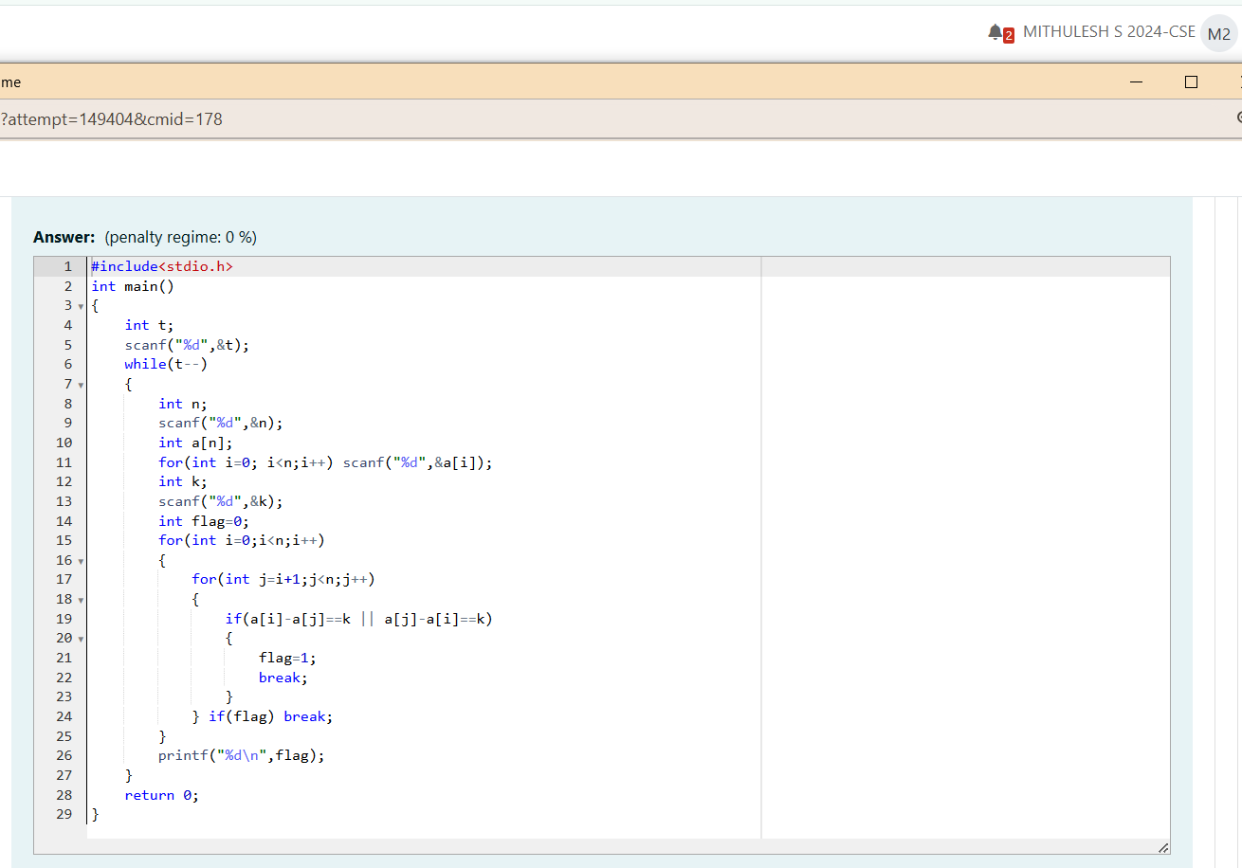

***Output***

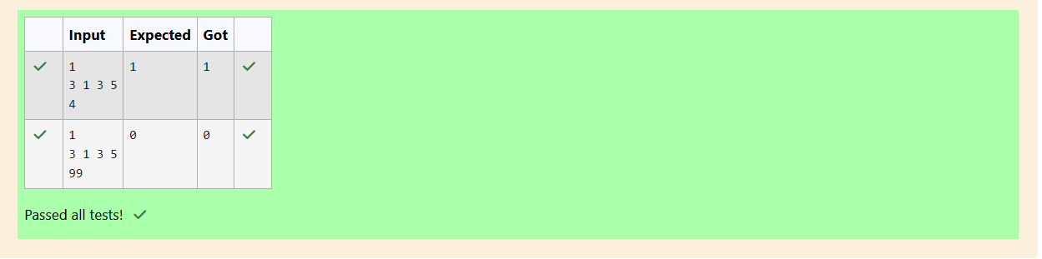

***Program 2***

*Sam loves chocolates and starts buying them on the 1st day of the year. Each day of the year, x, is numbered from 1 to Y. On days when x is odd, Sam will buy*

*x chocolates; on days when x is even, Sam will not purchase any chocolates.*

*Complete the code in the editor so that for each day Ni (where 1 x N Y) in array arr, the number of chocolates Sam purchased (during days 1 through*

*N) is printed on a new line. This is a function-only challenge, so input is handled for you by the locked stub code in the editor.*

*Input Format*

*The program takes an array of integers as a parameter.*

*The locked code in the editor handles reading the following input from stdin, assembling it into an array of integers (arr), and calling calculate(arr).*

*The first line of input contains an integer, T (the number of test cases). Each line i of the T subsequent lines describes the ith test case as an integer, Ni (the*

*number of days).*

*Constraints*

*105*

*1 s N s 2 x 106*

*Output Format*

*For each test case, Ti in arr, your calculate method should print the total number of chocolates Sam purchased by day Ni on a new line.*

*Sample Input 0*

*3*

*1*

*2*

*3*

*Sample Output 0*

*1*

*1*

*4*

*Explanation*

*Test Case 0: N = 1*

*Sam buys 1 chocolate on day 1, giving us a total of 1 chocolate. Thus, we print 1 on a new line.*

*Test Case 1: N = 2*

*Sam buys 1 chocolate on day 1 and 0 on day 2. This gives us a total of 1 chocolate. Thus, we print 1 on a new line.*

*Test Case 2: N = 3*

*Sam buys 1 chocolate on day 1, 0 on day 2, and 3 on day 3. This gives us a total of 4 chocolates. Thus, we print 4 on a new line.*

***Coding***

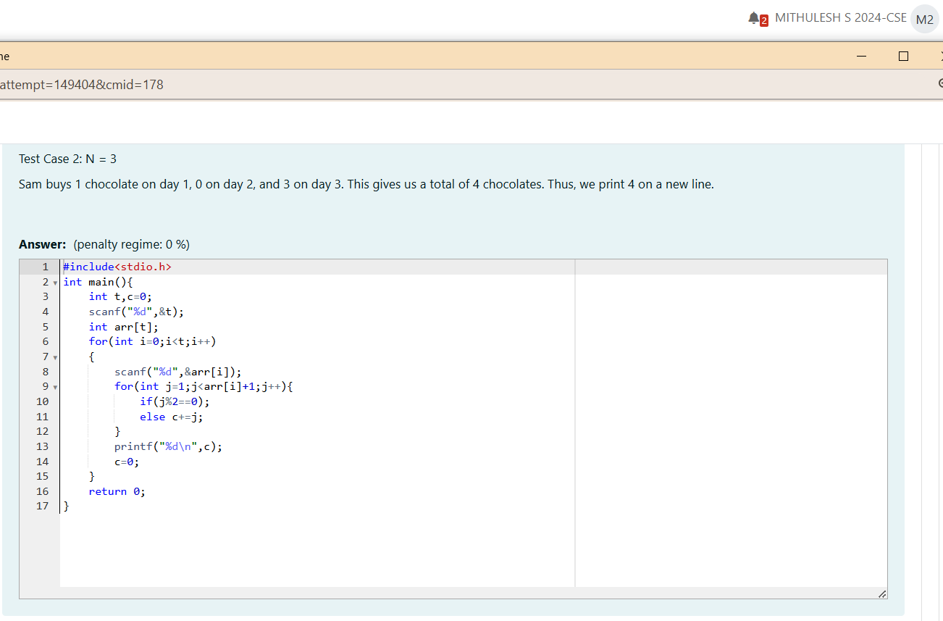

***Output***

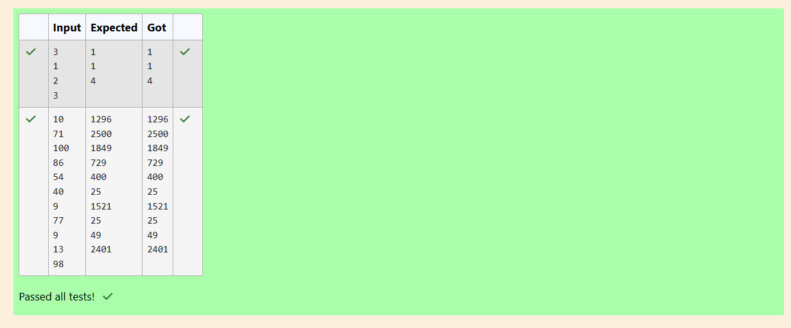

***Program 3***

*The number of goals achieved by two football teams in matches in a league is given in the form of two lists. Consider:*

*Football team A, has played three matches, and has scored { 1 , 2 , 3 } goals in each match respectively.*

*Football team B, has played two matches, and has scored { 2, 4 } goals in each match respectively.*

*Your task is to compute, for each match of team B, the total number of matches of team A, where team A has scored less than or equal to the number of*

*goals scored by team B in that match.*

*In the above case:*

*For 2 goals scored by team B in its first match, team A has 2 matches with scores 1 and 2.*

*For 4 goals scored by team B in its second match, team A has 3 matches with scores 1, 2 and 3.*

*Hence, the answer. {2, 3}.*

*Complete the code in the editor below. The program must return an array of m positive integers, one for each maxes[i] representing the total number of*

*elements numsÜ] satisfying numsÜ] maxes[i] where 0 sj < n and 0 i < m, in the given order.*

*It has the following:*

*nums[nums[0],...nums[n-1]]: first array of positive integers*

*second array of positive integers*

*Constraints*

*2 s n, m 105*

*1 numsÜ] 109, where 0 < j < n.*

*1 maxes[i] 109, where 0 i < m.*

*Input Format For Custom Testing*

*Input from stdin will be processed as follows and passed to the function.*

*The first line contains an integer n, the number of elements in nums.*

*The next n lines each contain an integer describing numsÜ] where 0 s j < n.*

*The next line contains an integer m, the number of elements in maxes.*

*The next m lines each contain an integer describing maxes[i] where 0 i < m.*

*Sample Case 0*

*Sample Input O*

*1*

*2*

*2*

*3*

*5*

*Sample Output O*

*2*

*Explanation 0*

*e are given n = 4, nums = [1, 4, 2, 41, m = 2, and maxes = [3, 5].*

*1.*

*2.*

*For maxes[0]*

*= 3, we have 2 elements in nums (nums[O]*

*For maxes[l] = 5, we have 4 elements in nums (nums[0] = 1, nums[l] = 4, nums[2] = 2, and nums[3]*

*= 1 and nums[2] = 2) that are maxes[0].*

*= 4) that are maxes[ll.*

*Explanation 1*

*We are given, n = 5, nums = [2, 10, 5, 4, 8], m = 4, and maxes = [3, 1, 7, 8].*

*2.*

*3.*

*4.*

*For maxes[0]*

*For maxes[3]*

*= 3, we have 1 element in nums (nums[0] = 2) that is maxes[O].*

*For maxes[ll = 1, there are 0 elements in nums that are maxes[l].*

*For maxes[21 = 7, we have 3 elements in nums (nums[O] = 2, nums[21 = 5, and nums[3] = 4) that are maxes[2].*

*= 8, we have 4 elements in nums (nums[O] = 2, nums[2J*

*= 5, nums[3] = 4, and nums[4] = 8) that are maxes[31.*

*Thus, the function returns the array [1, 0, 3, 4] as the answer.*

***Coding***

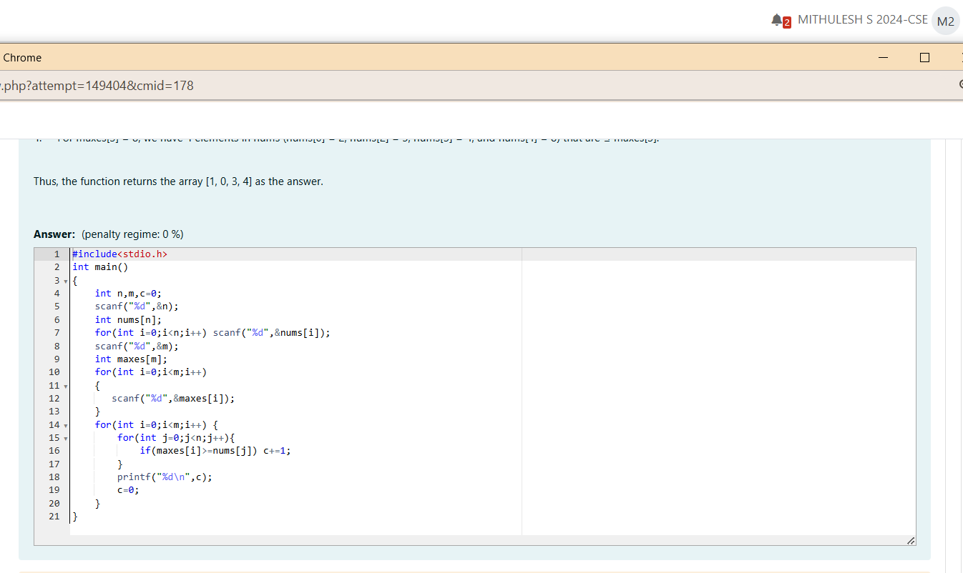

***Output***

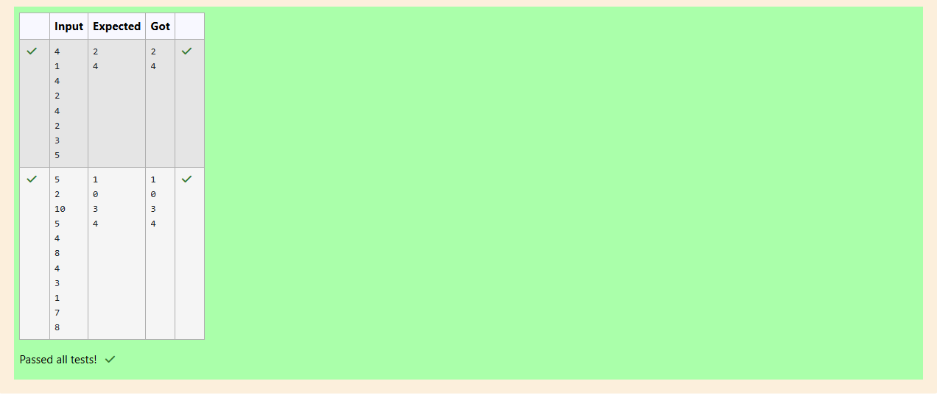

***Week 06 Coding***

***Program 1***

*Given an array of numbers and a window of size k. Print the maximum of numbers inside the window for each step as the window moves from the beginning*

*of the array.*

*Input Format*

*Input contains the array size, no of elements and the window size*

*Output Format*

*Print the maximum of numbers*

*Constraints*

*1 size 1000*

*Sample Input 1*

*8*

*13521869*

*3*

*Sample Output 1*

*555889*

***Coding***

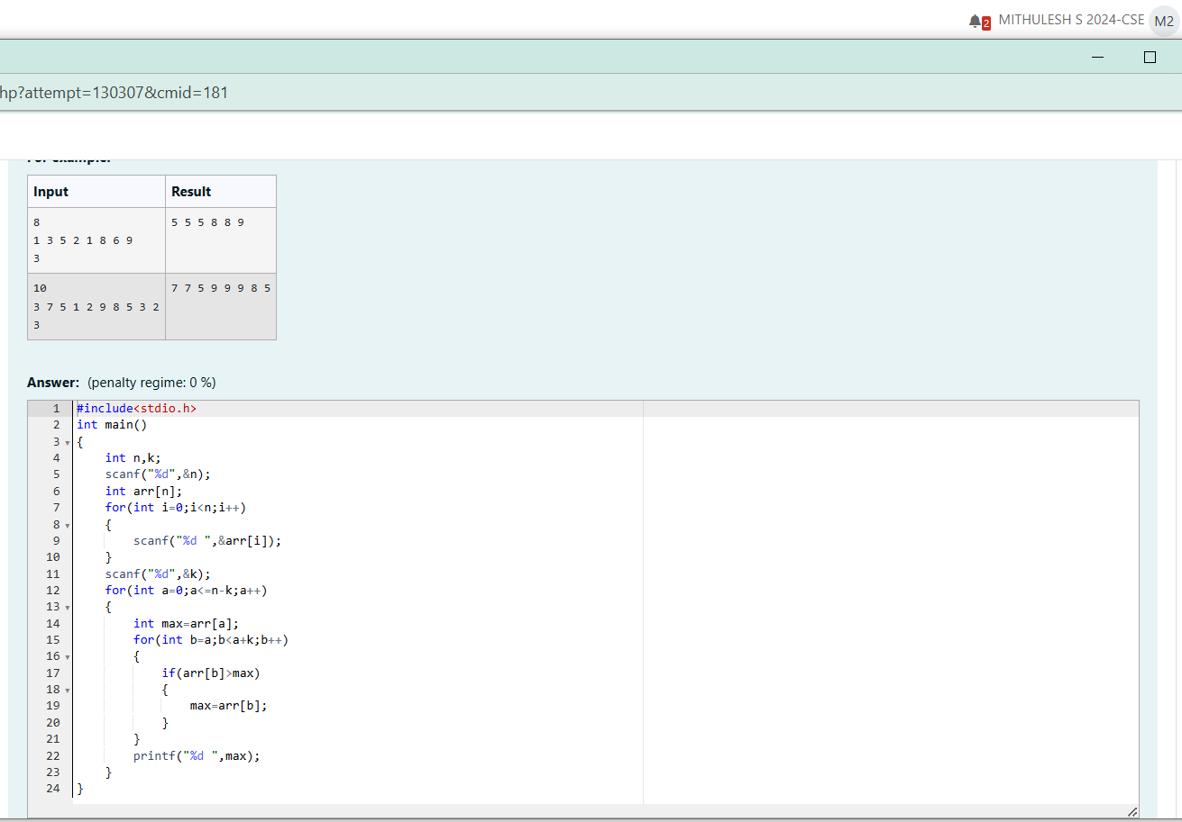

***Output***

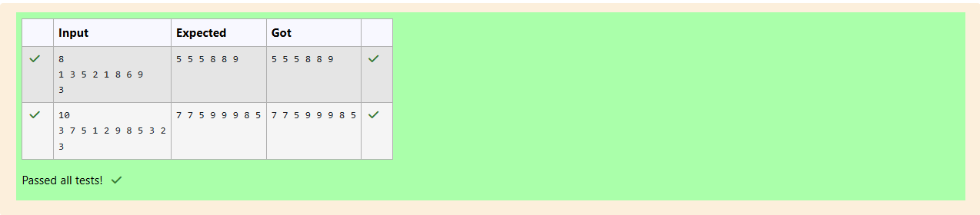

***Program 2***

*Given an array and a threshold value find the output.*

*Input:*

*Threshold = 3*

*Output count = 17*

*Explanation:*

*Number*

*5*

*8*

*10*

*13*

*6*

*2*

*Parts*

*{3,2}*

*{3,3}*

*{2}*

*Counts*

*2*

*3*

*4*

*5*

*2*

*Input Format*

*N - no of elements in an array*

*Array of elements*

*Threshold value*

*Output Format*

*Display the count*

*Sample Input 1*

*6*

*58101362*

*3*

*Sample Output 1*

*17*

***Coding***

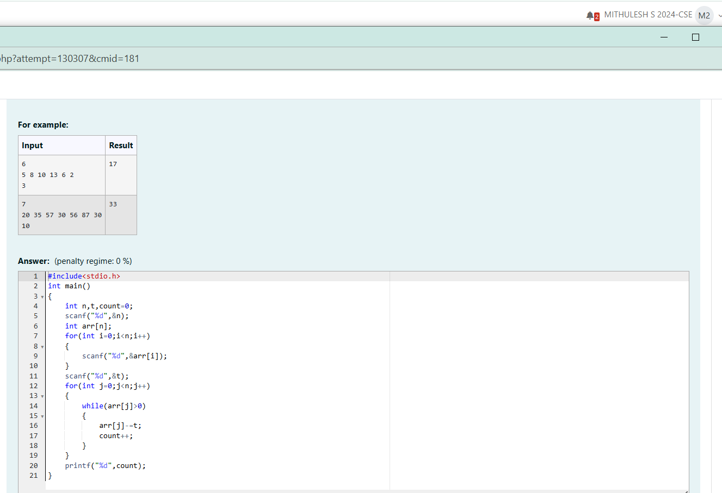

***Output***

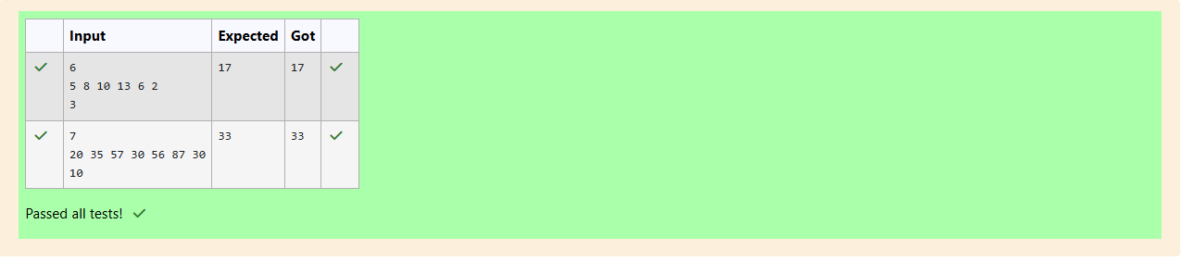

***Program 3***

*Output is a merged array without duplicates.*

*Input Format*

*NI - no of elements in array 1*

*Array elements for array 1*

*N2 - no of elements in array 2*

*Array elements for array2*

*Output Format*

*Display the merged array*

*Sample Input 1*

*5*

*12369*

*4*

*24510*

*Sample Output 1*

*123456910*

***Coding***

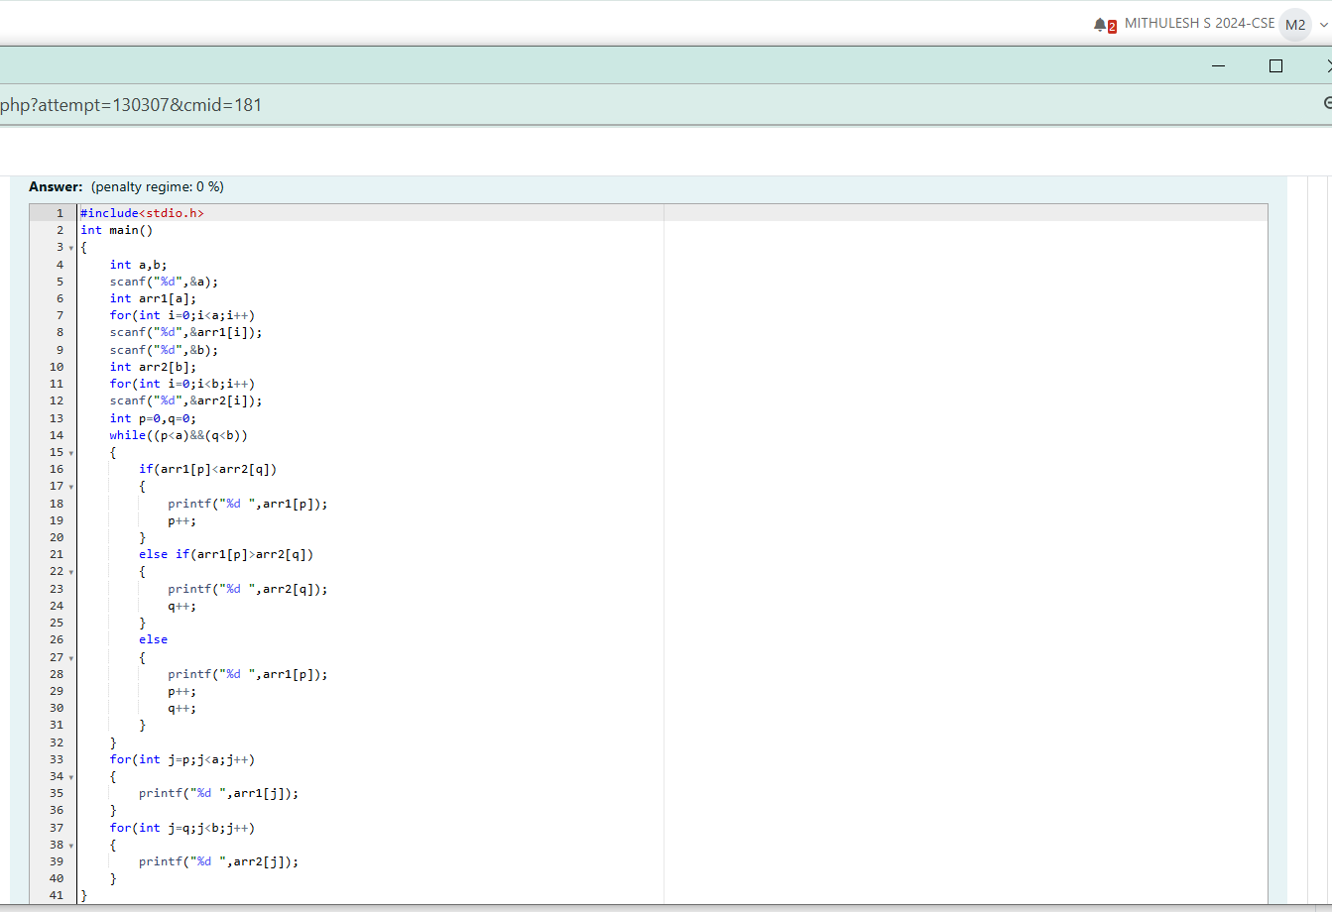

***Output***

